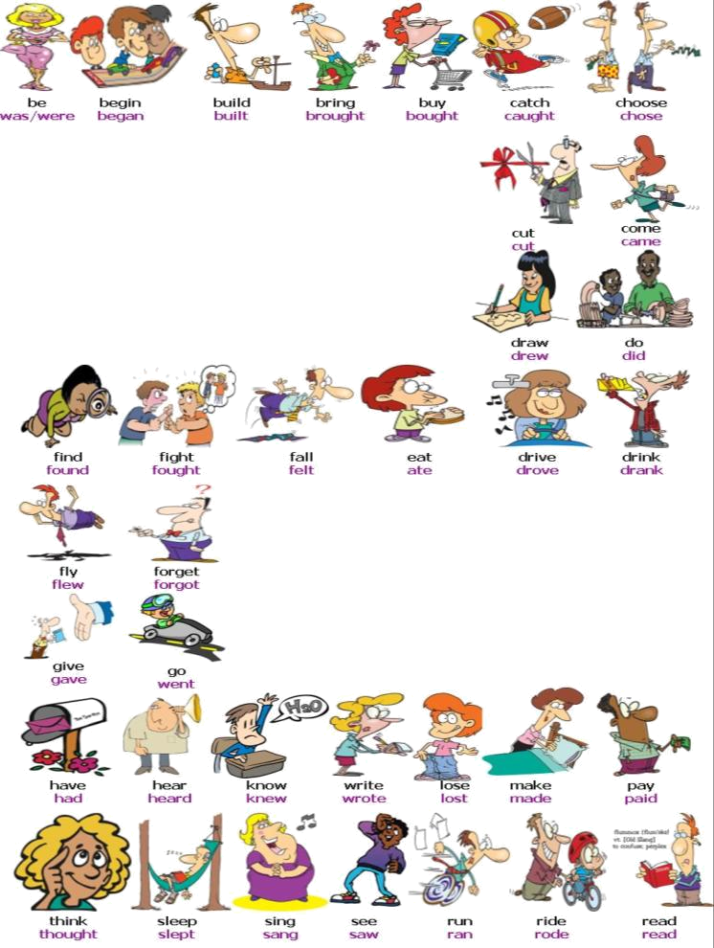
AFFIRMATIVE

I went
You went
He went
She went
It went
We went
You went
They went
NEGATIVE

I didn’t go
You didn´t go
He didn´t go
She didn´t go
It didn´t go
We didn´t go
You didn´t go
They didn´t go

QUESTION

Did I go?
Did you go?
Did he go?
Did she go?
Did it go?
Did we go?
Did you go ?
Did they go?

SHORT ANSWERS

Yes, I did
No, you didn´t
Yes, he did
No, she didn´t
Yes, it did
No, it didn´t
Yes, you did
No, they didn´t
USES: We use the Past Simple to talk about finished actions in the past.
- Some verbs are called irregular because their form in the past simple is considerably different from their infinitive form.
E.g.: go →went

- There is no rule to form the Past simple of Irregular verbs. That´s why their form must be learnt by heart.

- The past simple of irregular verbs keeps the same form for every person E.g.: I went, she went, they went…

Infinitive | Past simple
To be  To come  To cut  To eat  To drink  To feel  To go  To write  To read  To see  To leave  To sit  To sleep  To think  To know  To give  To tell  To throw | ____________________________________________  ____________________________________________  ____________________________________________  ____________________________________________  ____________________________________________  ____________________________________________  ____________________________________________  ____________________________________________  ____________________________________________  ____________________________________________  ____________________________________________  ____________________________________________  ____________________________________________  ____________________________________________  ____________________________________________  ____________________________________________  ____________________________________________  ____________________________________________
Write these verbs in the past simple:
Fill in the blanks with the missing verb in the past simple.
- Yesterday Mary _________ (go) to the concert.
- Last night _________ (not/be) cold, but it _________(be) rainy.
- Last Tuesday morning my friends _________(bring) the car.
- Last weekend we _________(not/go back) on foot.
- Mark and Sue _________(do) their homework after lunch.
- My friends _________(come) over after dinner.
- The teacher _________(know) them and _________ (be) very happy.

Build sentences with the words given and put the verbs in the past simple.

- easy / test / the / be _____________________________________________________
- home / 11 o´clock / at / they / come ________________________________________
- cinema / they / last night / go / to the ______________________________________
- book / of the / they / know / the story _____________________________________
- washing up / do / my mother / the ________________________________________

http://www.englishexercises.org/makeagame/viewgame.asp?id=7605http://www.englishexercises.org/makeagame/viewgame.asp?id=7605
Make the sentences negative
- Mary told me the test was easy.
- ____________________________________________________________________________
- They went to Lisbon by car.
- ____________________________________________________________________________
- The rabbits grew fast.
- ____________________________________________________________________________
- I found my book under the bed.
- ____________________________________________________________________________
- He wrote me a letter last week.
- ____________________________________________________________________________
- She caught the bus at the bus station.
- ____________________________________________________________________________
- I did my homework after lunch.
- ____________________________________________________________________________

Write a short text about yesterday and try to answer these questions:
What did you do in the morning? What did you do in school? What did you do in the afternoon? What did you do in the evening? What did you NOT do? Who was with you?

____________________________________________________________________________________________________________________________________________________________________________________________________________________________________________________________________________________________________________________________________________________
__________________________________________________________________________________________________________________________________________________________________________
__________________________________________________________________________________________________________________________________________________________________________
__________________________________________________________________________________________________________________________________________________________________________

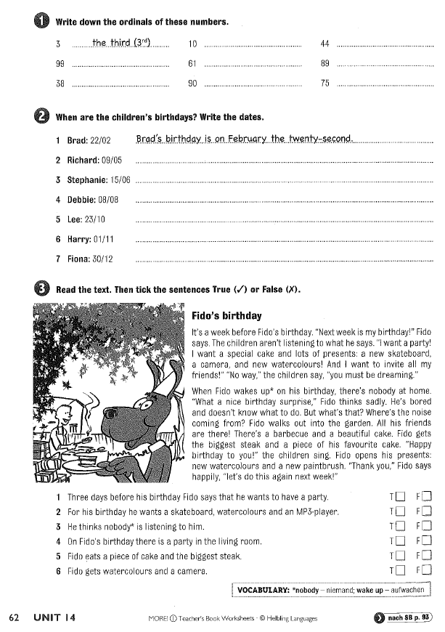
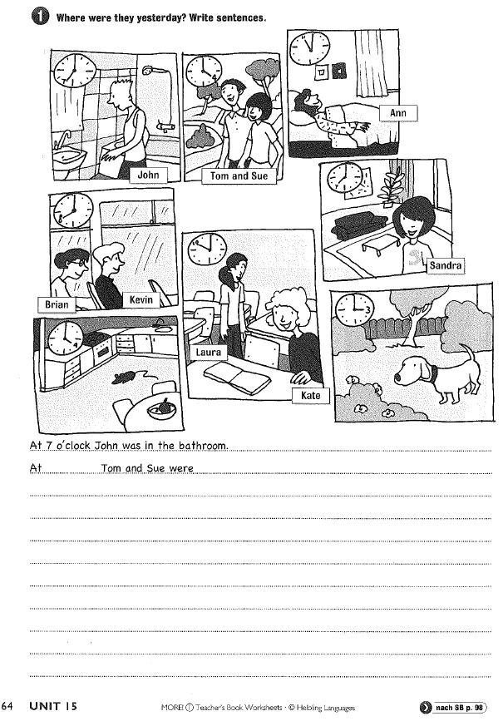
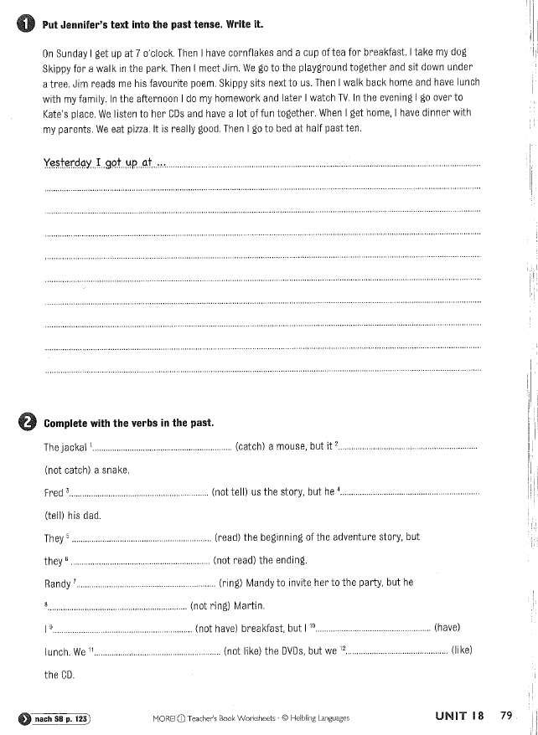
1) Write down at least 5 questions you can ask another person about his/ her TV habits!

2) Write a text about your TV habits. Answering the questions of number 1!

Write a text about the last book you read! (You can also choose the English book) Try to answer these questions with your text:
What is the name of the book?
Who are the main characters?
What is the BIG TOPIC (große Thema)?
What is very important (wichtig) to know?
What do you like best?
Why do you like the book?

Write a text about your favourite film! (You can also choose your favourite TV programme) Try to answer these questions with your text:
What is the name of the film?
Who are the main characters?
What is the BIG TOPIC (große Thema)?
What is very important (wichtig) to know?
What do you like best?
Why do you like the film?

ONLINE ÜBUNGEN
https://quizlet.com/de WORDS AND PHRASES

http://www.englisch-hilfen.de/exercises_list/zeitformen.htm PRESETN AND PAST SIMPLE
- Present Simple ALLES
- Past Simple: 4410, 4412, 3616, 3618, 418, 4120, 4114, 4116, 4126, 4128
https://learningapps.org/2264215 ASKING QUESTIONS
https://learningapps.org/2046597 QUESTION WORDS
http://www.englisch-hilfen.de/uebungen/strukturen/praepositionen_zeitangaben3.htm TIME PREPOSITIONS

https://www.ego4u.de/de/cram-up/vocabulary/numbers/ordinal ORDINAL NUMBERS
http://www.englishexercises.org/makeagame/viewgame.asp?id=7605 HOW MUCH IS/ ARE

